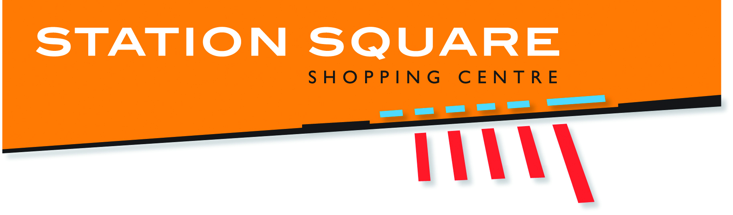

2018 STATION SQUARE SPELLING BEE
EXPRESSION OF INTEREST
Would your school like to participate in our 2018 Spelling Bee at Station Square Shopping Centre? We aim to hold the 2018 Spelling Bee on the following dates:
Category 1 Grade 3 & 4 Sat, 13 October 2018 9am
Category 2 Grade 5 & 6 Sat, 13 October 2018 11am*
Category 3 Grade 7 & 8 Sat, 20 October 2018 9am
Category 4 Grade 9 & 10 Sat, 20 October 2018 11am*
Semi-Final Sat, 27 October 2018 9am
Final Sat, 27 October 2018 11am*
*11am time may change depending on number of schools interested

SCHOOL: ____________________________________________________________________

Principal’s name and signature approval required to register your expression of interest to participate in the 2018 Station Square Spelling Bee.

*Please include any Teacher/s that will be coordinating all future Spelling Bee related information, if the school Principal is not applicable*

SCHOOL POSTAL ADDRESS: __________________________________________________________

__________________________________________________________________________________

PRINCIPAL NAME: ___________________________________SIGNATURE:____________________

CONTACT TEACHER NAME (if applicable):______________________________________________

EMAIL: ____________________________________________________________________________

THIS PROMOTION INVOLVES ALL SCHOOLS IN THE FRASER COAST REGION REGISTERING TEAMS OF THREE STUDENTS TO PARTICIPATE.
Please return completed forms to Daisy Murray at dcrabtree@green-group.net, or post Centre Management, Station Square Shopping Centre, 142 Lennox St, Maryborough, QLD 4655 ASAP
