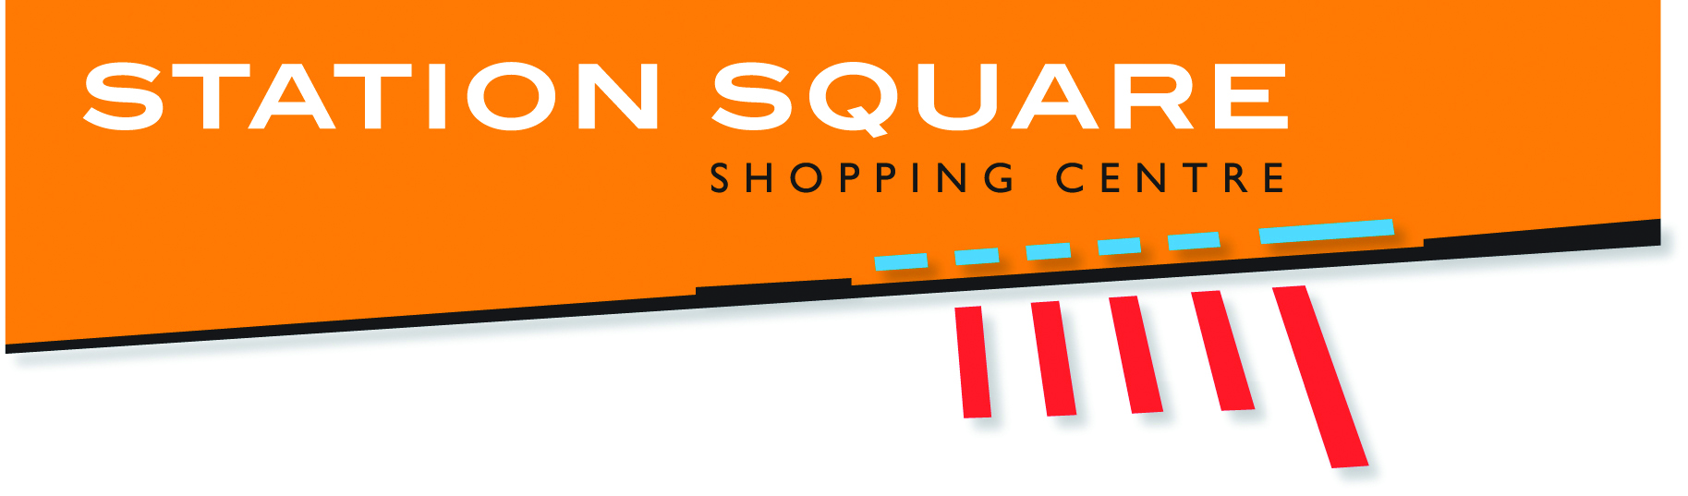
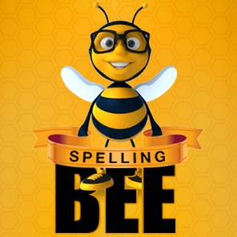

2018 STATION SQUARE SHOPPING CENTRE SPELLING BEE
TEAM REGISTRATION FORM
*Maximum of 2 teams per school per category. 3 students per team required*

SCHOOL NAME: ____________________________________________________________________

Principal’s name and signature approval required for their student/s to represent the above mentioned school and participate in the Station Square Shopping Centre Spelling Bee 2018.

SCHOOL’S POSTAL ADDRESS: _________________________________________________________

__________________________________________________________________________________

PRINCIPAL’S NAME: ___________________________________SIGNATURE:____________________

SCHOOL REPRESENTATIVE FOR SPELLING BEE;

NAME: ________________________________ CONTACT NUMBER:_____________________
EMAIL: ______________________________________________________________________

THIS PROMOTION INVOLVES SCHOOLS ON FRASER COAST REGISTERING A TEAM OF THREE STUDENTS IN ANY OR ALL THREE CATEGORIES OF THE SPELLING BEE (MAXIMUM OF 2 TEAMS PER SCHOOL, PER CATEGORY)

Category 1 Grade 3 & 4 Sat, 13 October 2018 from 9am
Category 2 Grade 5 & 6 Sat, 13 October 2018 from 11am*
Category 3 Grade 7 & 8 Sat, 20 October 2018 from 9am
Category 4 Grade 9 & 10 Sat, 20 October 2018 from 11am*
Semi-Final Sat, 27 October 2018 from 9am
Final Sat, 27 October 2018 from 11am*

*11am time may change depending on numbers

PLEASE INCLUDE -
- REGISTERED STUDENT NAME’S
- PARENT OR GUARDIAN NAME, CONTACT NUMBER & SIGNATURE

TEAM 1
Category/Year Level (tick)
☐3 & 4 ☐5 & 6 ☐7 & 8 ☐9 & 10

NAME:
NAME:
NAME

TEAM 2
Category/Year Level (tick)
☐3 & 4 ☐5 & 6 ☐7 & 8 ☐9 & 10

NAME:
NAME:
NAME

STUDENT NAME
CATEGORY ☐3 & 4 ☐5 & 6 ☐7 & 8 ☐9 & 10
PARENT/CARER NAME
CONTACT NUMBER
I GIVE PERMISSION FOR MY CHILD TO PARTICIPATE IN THE 2018 STATION SQUARE SPELLING BEE
SIGNATURE DATE

STUDENT NAME
CATEGORY ☐3 & 4 ☐5 & 6 ☐7 & 8 ☐9 & 10
PARENT/CARER NAME
CONTACT NUMBER
I GIVE PERMISSION FOR MY CHILD TO PARTICIPATE IN THE 2018 STATION SQUARE SPELLING BEE
SIGNATURE DATE

STUDENT NAME
CATEGORY ☐3 & 4 ☐5 & 6 ☐7 & 8 ☐9 & 10
PARENT/CARER NAME
CONTACT NUMBER
I GIVE PERMISSION FOR MY CHILD TO PARTICIPATE IN THE 2018 STATION SQUARE SPELLING BEE
SIGNATURE DATE
In the event that a registered entrant is unable to attend, the school can advise 24 hours prior to their scheduled Heat Date the replacements name.
Please note: The replacement entrant will be required to complete this form, including the parent or guardians approval section to be completed.

AS PER ABOVE, THE DATES THAT STUDENTS WILL BE PARTICIPATING IN THE SPELLING BEE COMPETITIONS ARE AS FOLLOWS:

- Category 1 Grade 3 & 4 Sat, 13 October 2018 from 9am
- Category 2 Grade 5 & 6 Sat, 13 October 2018 from 11am
- Category 3 Grade 7 & 8 Sat, 20 October 2018 from 9am
- Category 4 Grade 9 & 10 Sat, 20 October 2018 from 11am
- Semi-Final Sat, 27 October 2018 from 9am
- Final Sat, 27 October 2018 from 11am

We ask that in representing their School, that students partaking in the Station Square Shopping Centre Spelling Bee dress in their School Uniform accordingly for this Competition.

TERMS AND CONDITIONS OF THE 2018 STATION SQUARE SHOPPING CENTRE SPELLING BEE ARE AVAILABLE FROM STATION SQUARE SHOPPING CENTRE MANAGEMENT OFFICE, OR AT www.stationsquare.com.au

REGISTRATION FORMS ARE DUE NO LATER THAN
THURSDAY 13 SEPTEMBER 2018

REGISTRATION FORMS CAN BE RETURNED VIA THE BELOW METHODS:
- HAND DELIVERED TO STATION SQUARE SHOPPING CENTRE CENTRE MANAGEMENT OFFICE
- POST – STATION SQUARE SHOPPING CENTRE, CENTRE MANAGEMENT, 142 LENNOX ST, MARYBOROUGH, QLD 4650
- SCANNED & EMAIL TO DAISY MURRAY: dcrabtree@green-group.net

